**Globaly :**

For the firm that rely heavily on petroleum we logicaly observe a strong correlation between their income and the price of the brent and on the price of the stock.

It is not that easy to find information about old event to understand why sometimes the stock prices change so fast.

**Two firms do not produce oil and one is an investment trust. Is that ok ?**

1. **Exxon Mobile**



**Fondation :** November 30, 1999; 16 years ago, merge of Exxon and Mobile

**Product** : crude oil oil products natural gas petrochemicals

**To be noted :** steady Growth

1. **Apache Corp**

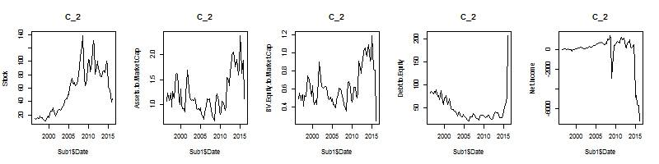

**Fondation :** 1954

**Product :** Petroleum (at the lecture of their annual report they seems to rely very heavily on petroleum), Natural Gaz

**To be noted :** Stock price follow the price of petroleum. Stock very sensitive to the recent fall of petroleum. Probably due to the specialisation of Apache in Petroleum when other firm have different source of revenu (<https://www.thestreet.com/story/12977943/1/apache-corp-apa-stock-hits-one-year-low-as-oil-prices-dip-to-five-year-low.html)>

1. **CenterPoint Energy Inc**

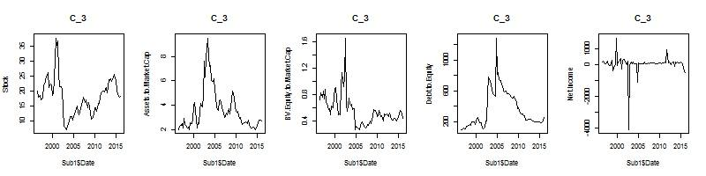

**Fondation :** 1882

**Product :** electric and natural gas !!!

**To be noted :**

The brutal drop in 2003/2004 corresponds to the restructuration of the Texas State-regulated energy firm that lead to the creation of Center Point in her current form.

When the state of Texas deregulated the electricity market, the former [Houston Lighting & Power](https://en.wikipedia.org/wiki/Houston_Lighting_%26_Power) (HL&P) was split into several companies.[[4]](https://en.wikipedia.org/wiki/Texas_Genco#cite_note-Exelonbids-4) In 2003 HL&P was split into [Reliant Energy](https://en.wikipedia.org/wiki/Reliant_Energy), Texas Genco, and [CenterPoint Energy](https://en.wikipedia.org/wiki/CenterPoint_Energy).[[5]](https://en.wikipedia.org/wiki/Texas_Genco#cite_note-Fowler-5)`

Seeking opportunities arising out of the deregulation of the electricity industry in Texas, in late 2004 four private equity firms—the [Texas Pacific Group](https://en.wikipedia.org/wiki/Texas_Pacific_Group), the [Blackstone Group](https://en.wikipedia.org/wiki/Blackstone_Group), [Kohlberg Kravis Roberts](https://en.wikipedia.org/wiki/Kohlberg_Kravis_Roberts), and [Hellman & Friedman](https://en.wikipedia.org/wiki/Hellman_%26_Friedman) of San Francisco—combined forces to purchase Texas Genco from the transmission & distribution provider utility [Centerpoint Energy](https://en.wikipedia.org/wiki/Centerpoint_Energy) for Houston

<http://www.sec.gov/divisions/investment/opur/filing/35-27921.htm>

1. **Chevron Corp**



**Fundation :** 1879 as Pacific Coast Oil Company and 1984 as Chevron Corporation

**Products :** Petroleum, natural gas and other petrochemicals

**To be noted : Steady Growth, Hypothesis of strong impact of Oil price drop on stock price**

1. **Hess Corp**

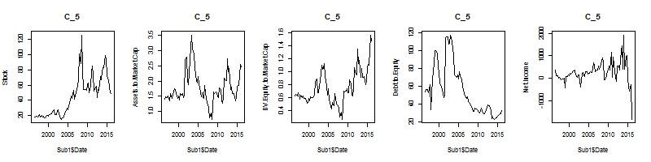

**Founded :** 1919

**Product :** Oil and Gaz

**To be noted :** 2008 crisis, last two quarter are very bad -

1. **Murphy Oil Corporation**



Fondation : 1950

Products : Petroleum, Natural gas

To be noted : same at the others that, probably very dependent on the Brent price

1. **Occidental Petroleum Corp**

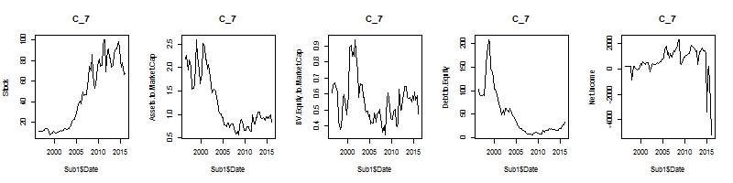

**Fondation :** 1920

**Product :** Oil, Natural Gaz and Petrochimicals

**To be noted :** Not much, effect of the drop in oil price also very visible

1. **PG&E Corp**

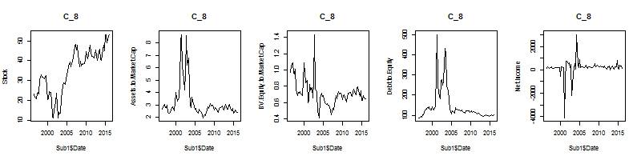

**Fondation : 1905**

**Product :** Electricity and Gaz …

**To be noted :** well they do not produce oil…. Very visible in their stock and Net income stream

Nearly went bankrupt in 2001/2002 : « Pacific Gas & Electric Co., California's largest utility, filed Friday for bankruptcy protection from creditors because of unreimbursed power costs that are now running at more than $300 million a month »

http://money.cnn.com/2001/04/06/news/pacificgas/

1. **Williams Cos In**

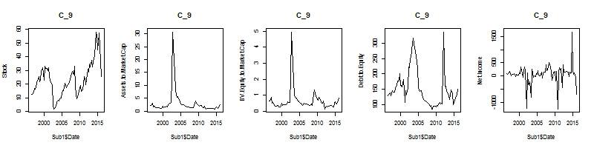

**Fondation :** 1908

**Product :** Oil and Natual gaz

**To be noted :** Nearly went bankrupt in 2002 :

« Troubled energy firm Williams Cos. received a much-needed hand from Warren Buffett and the company's banks Thursday in the form of $3.4 billion in financing that will help stave off a bankruptcy filing this week.

Williams and other energy companies have come under pressure because of recent industry turmoil sparked by the collapse of Enron Corp. over an accounting scandal. »

**http://money.cnn.com/2002/08/01/news/companies/williams_buffett/**